Tasks To Be Performed:

1. Use the previous deployment

2. Change the service type to ClusterIP

**Procedure: -**

**We need to change the service nodeport to clusterIP**

**The command is “kubectl edit service nginx-service”**

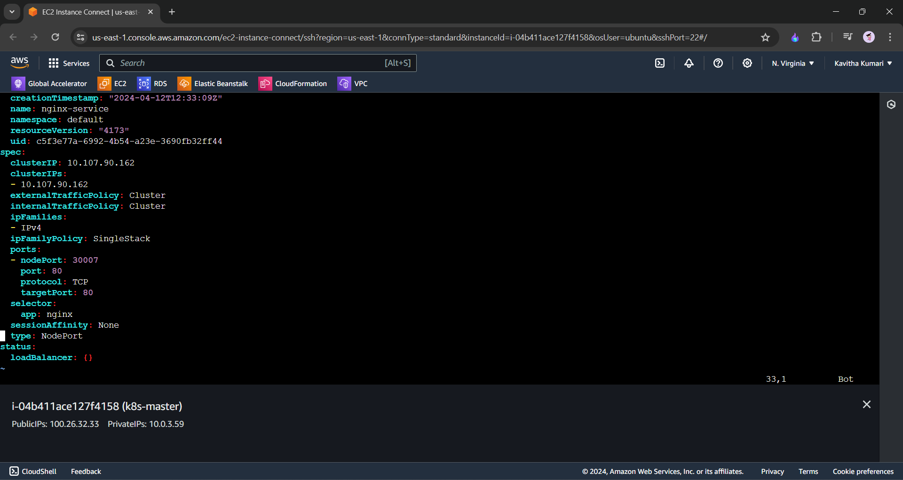

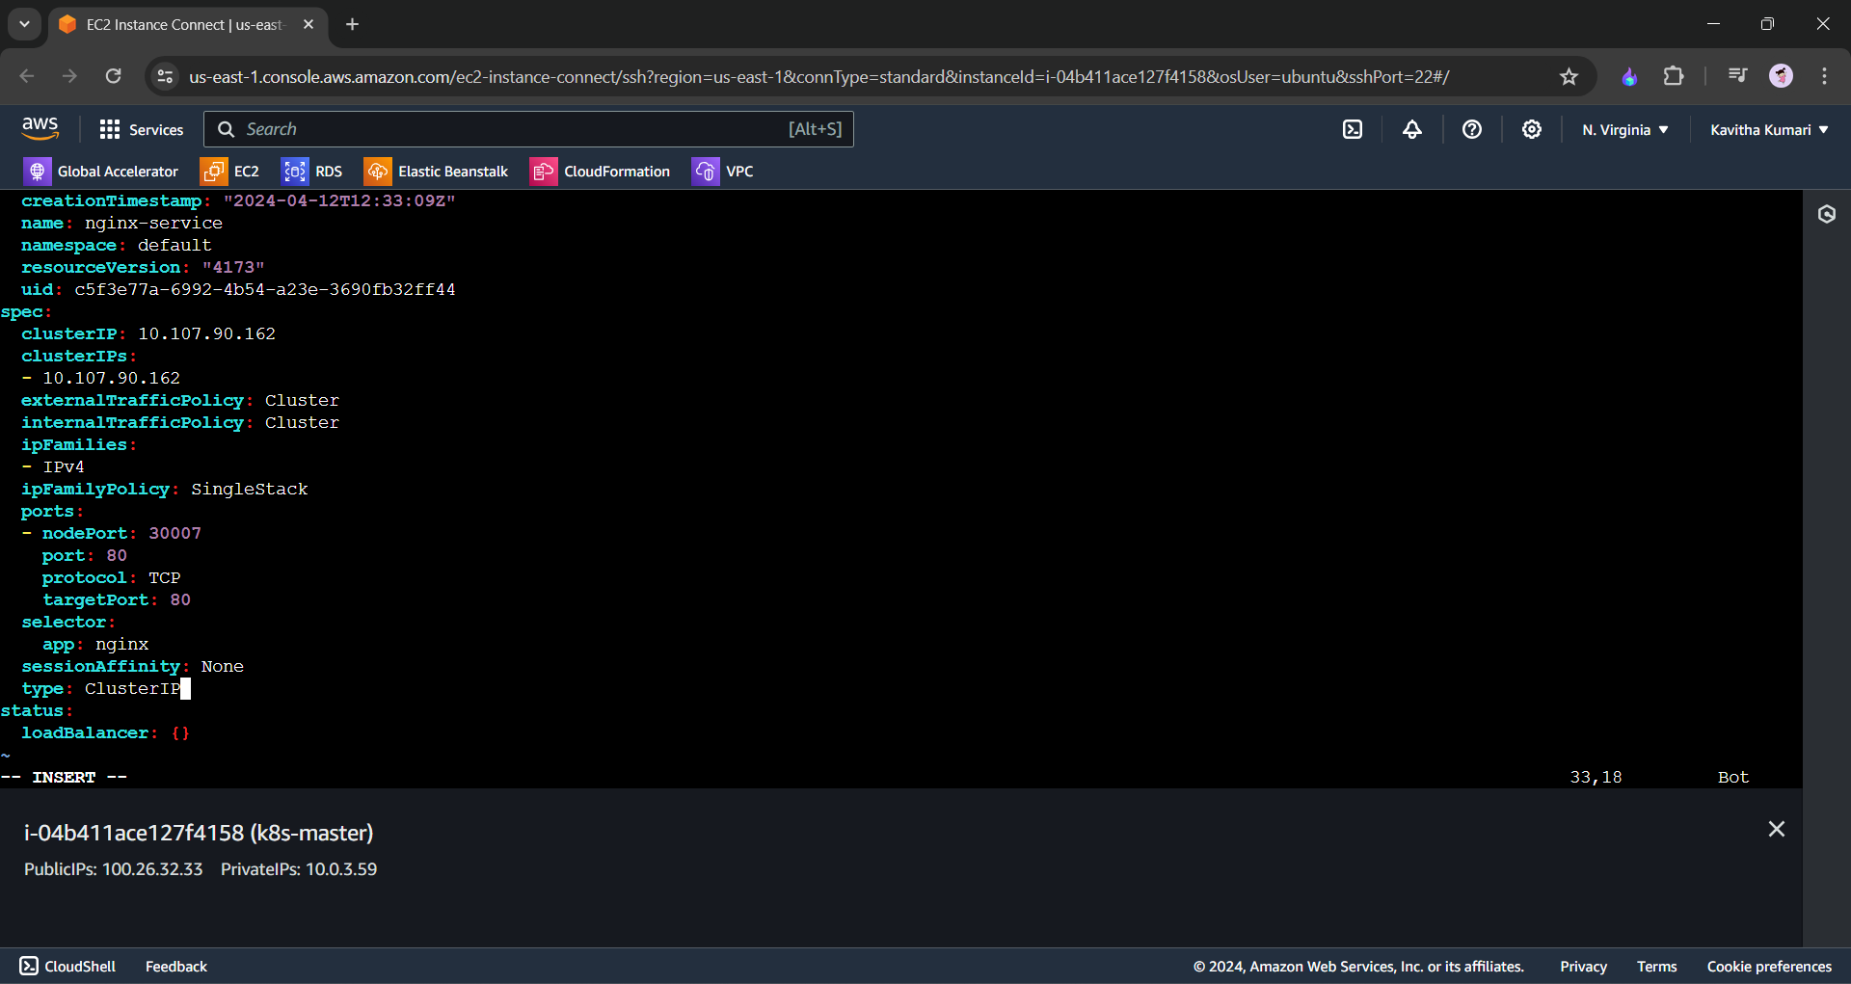

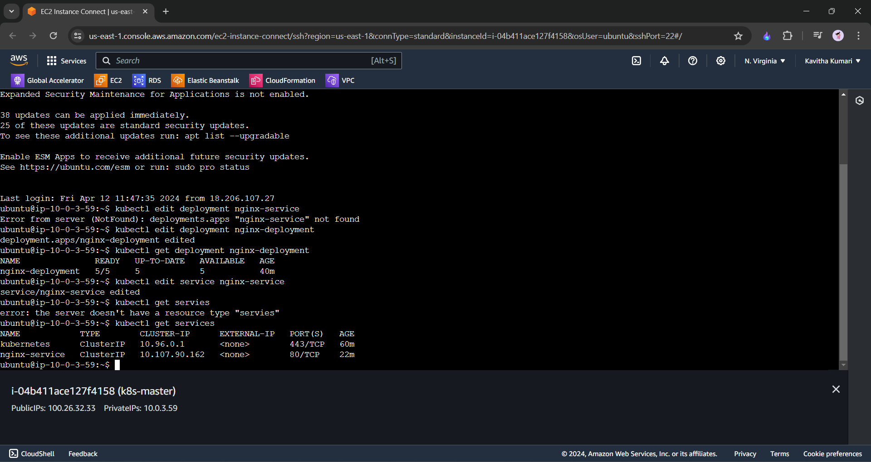

**---------end----------------**